**Getting Up and Running With Jupyter Notebook**

### **1.Installation**

Type the following command on terminal to setup

$ pip install jupyter

### **Starting the Jupyter Notebook Server**

$ jupyter notebook

This will start up Jupyter and your default browser should start (or open a new tab) to the following URL: <http://localhost:8888/tree>

[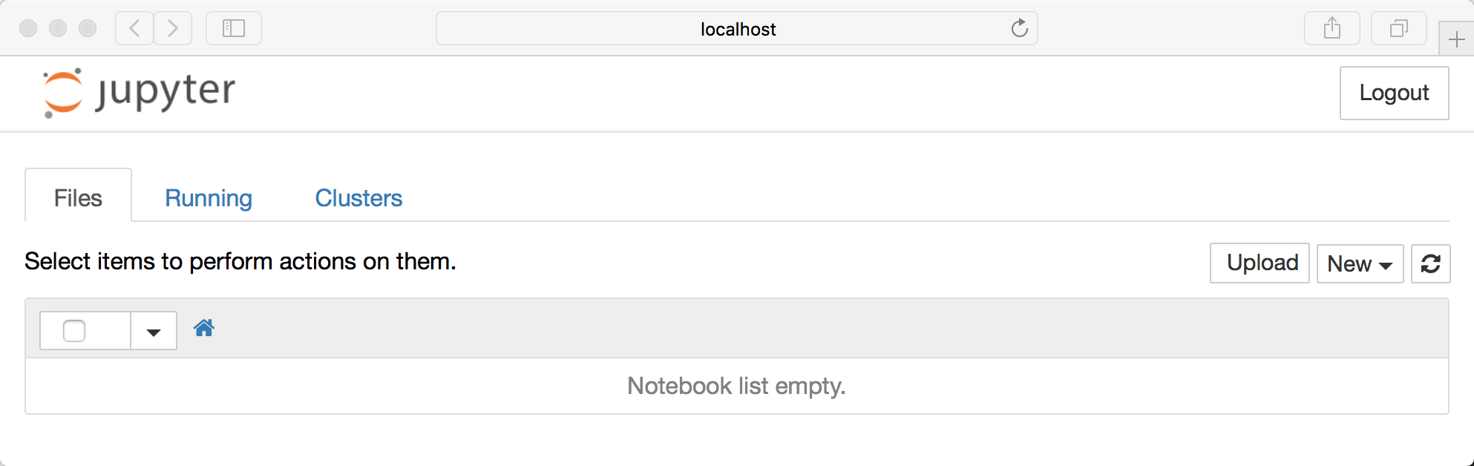](https://files.realpython.com/media/01_initial_notebook_screen.cb2ea87d9679.png)Note that right now you are not actually running a Notebook, but instead you are just running the Notebook server.

## 2.Creating a Notebook

All you need to do is click on the *New* button (upper right) and then your webpage looks like this :

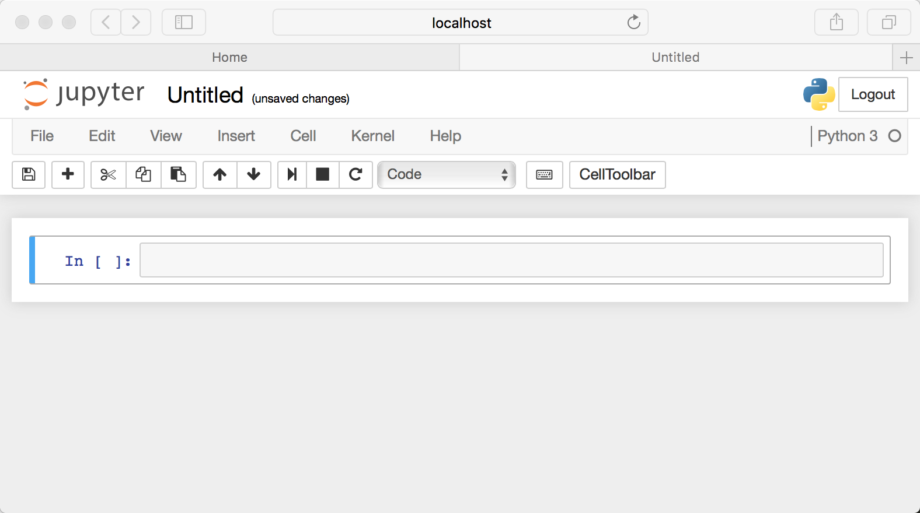

**3.Naming**

You will notice that at the top of the page is the word Untitled. This is the title for the page and the default name of your Notebook

Let’s rename this one to *Hello Jupyter*:

[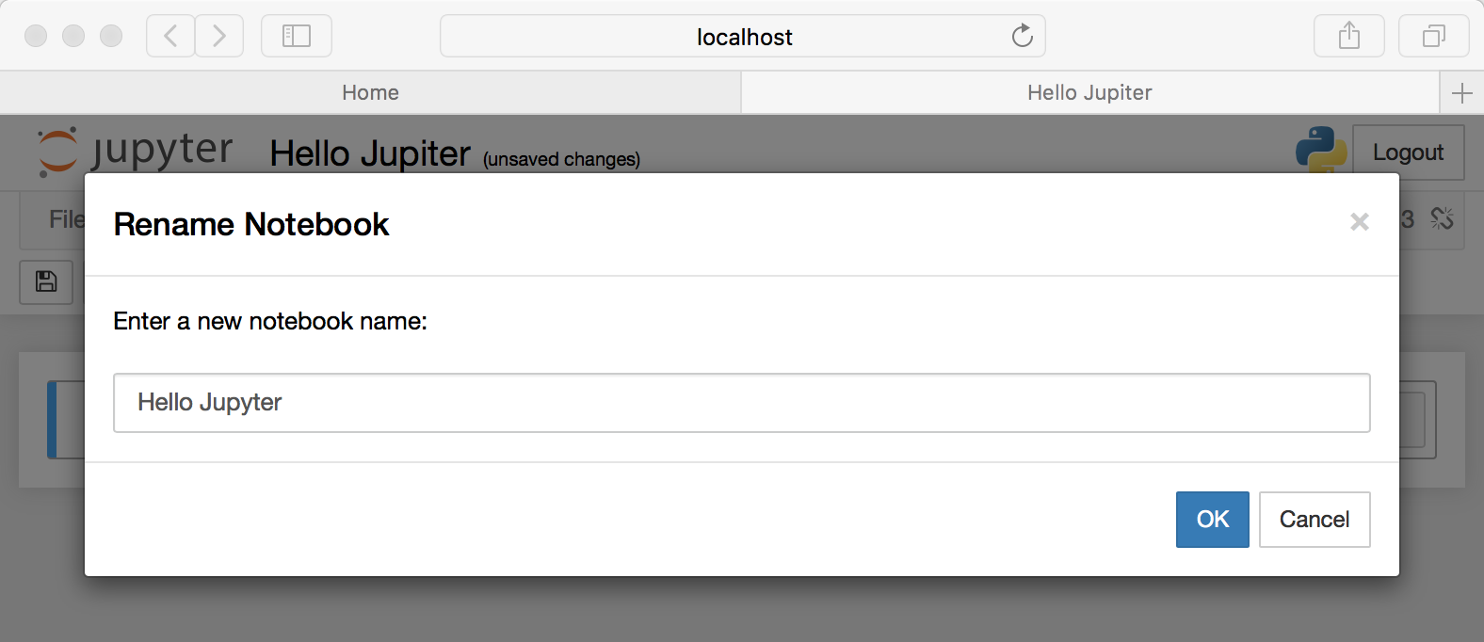](https://files.realpython.com/media/03_hello_jupyter.96024ca79ae6.png)

### **4.Running Cells**

Let’s try adding the following code to that cell:

print('Hello Jupyter!')

When I ran the code above, the output looked like this:

[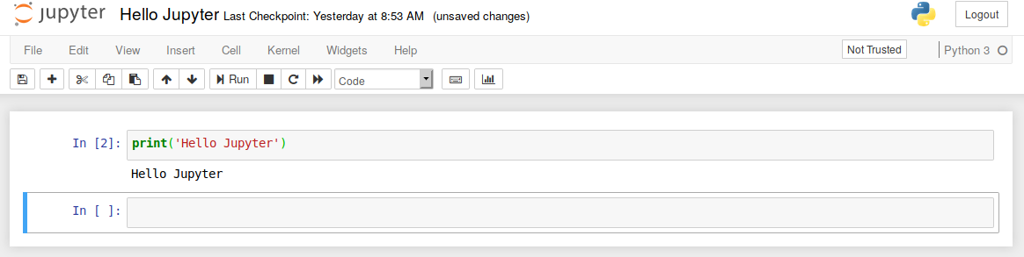](https://files.realpython.com/media/04_cell_run.73e945f90bb1.png)

### **4.1Styling Your Text**

Set a new cell to Markdown and then add the following text to the cell:

[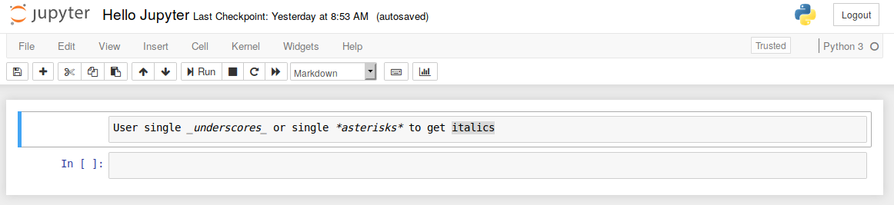](https://files.realpython.com/media/05_italic.e9e16a1040f5.png)

When you run the cell, the output should look like this:

[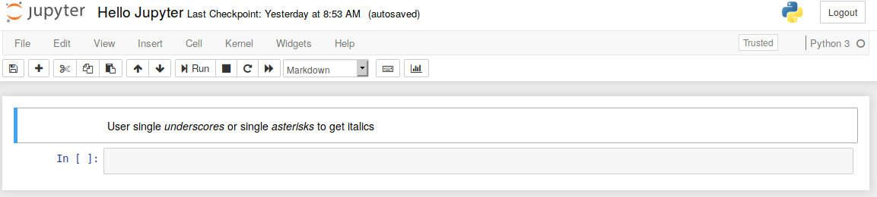](https://files.realpython.com/media/06_italic_ran.63ba240b2492.png)

If you would prefer to bold your text, use a double underscore or double asterisk.

### **4.2Headers**

Creating headers in Markdown is also quite simple.

[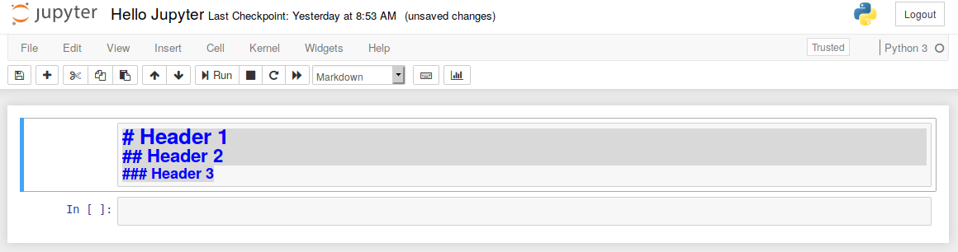](https://files.realpython.com/media/07_headers.dc5aa8999b03.png)

Then when you run the cell, you will end up with a nicely formatted header:

[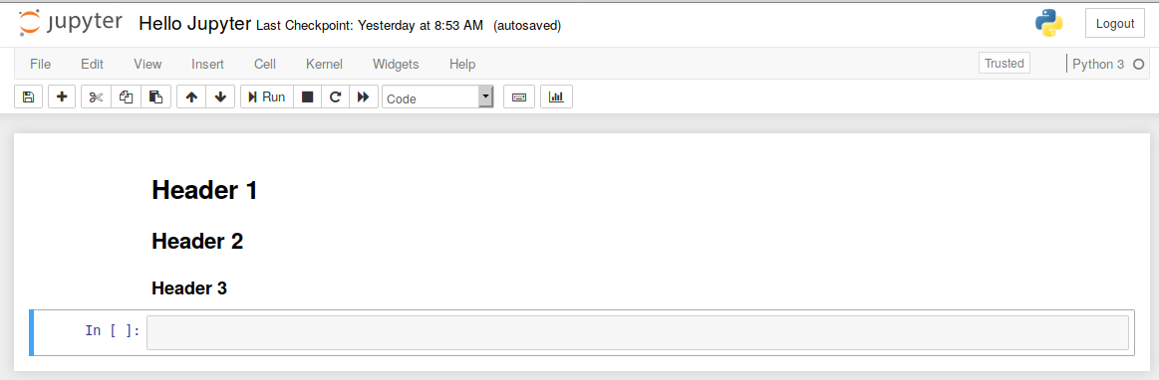](https://files.realpython.com/media/08_headers.9cfb98853821.png)

### **4.3Creating Lists**

You can create a list (bullet points) by using dashes, plus signs, or asterisks. Here is an example:

[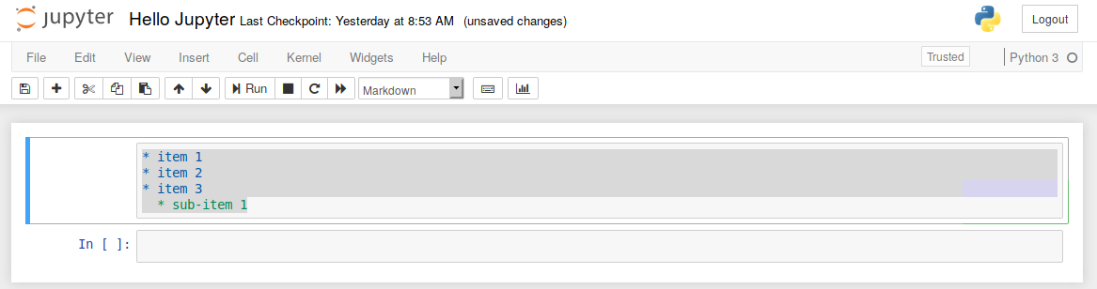](https://files.realpython.com/media/09_list.bb44656fd178.png)